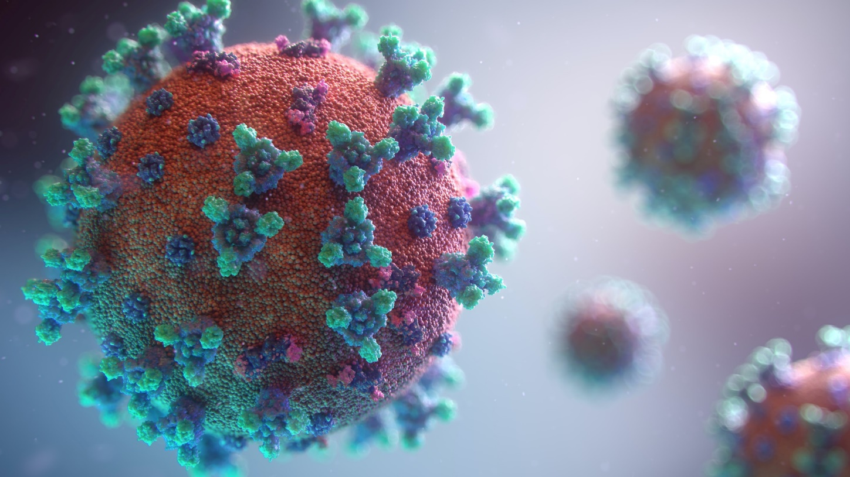

If you are over 16 and would like to take part then please visit [bit.ly/PIOC19-3](https://southernhealthnhs.fra1.qualtrics.com/jfe/form/SV_7VfclSTO2zib1JQ) or scan the QR code

Researchers are inviting you to take part in a short, online questionnaire about the impact coronavirus has had on your life. This information will be used to support our understanding of how the pandemic and changing restrictions may be affecting our mental health and wellbeing.

Help us understand the psychological impact of Coronavirus